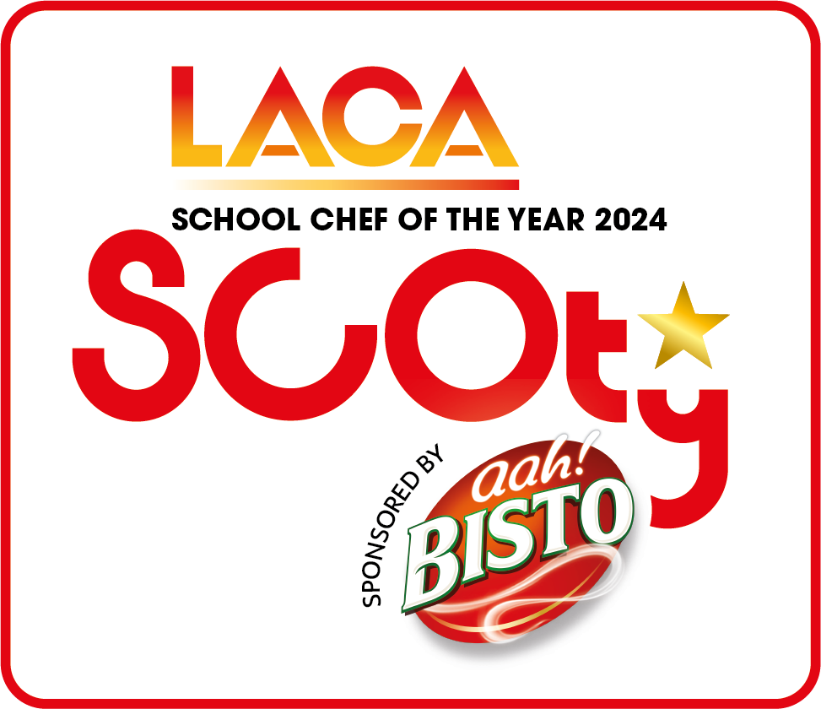
LACA SCHOOL CHEF OF THE YEAR 2024
- ENTRY CHECKLIST

DEVISING YOUR MENUS

- Study the competition rules and pay particular attention to rule 5 which relates to the School Food Standards and the Eat Well Guide 2016 and will form the basis of your recipes.

- The main course must include one Bisto product from the list provided. Competitors are permitted to use more than one Premier Foods product in their main course if it suits the dish.

- The dessert should be based on 50% fruit content and include at least one item from the list of Premier Foods dessert products provided. Please note: Items highlighted in grey may be used but don't count as the Premier ingredient in the recipe so must be used in addition with other ingredients on the list.

- The judges are looking for skills and innovation in the use of sponsor ingredients, preparation, cooking and presentation of dishes.

- The menu meal cost is a maximum of £1.60 for one single meal for one pupil, ie one main course and one dessert. NB: contestants should use the full allowance for their menu, there are no extra points awarded for using less than the full allowance.

- A Standard Ingredient Costing Sheet and costs for the Bisto and Premier Foods products are provided – you must use the costs from this sheet if using any of the ingredients listed. Other ingredients not on the lists can be used but must be costed correctly and evidence of your costs may be requested. Please note – all ingredients must have a cost against them even those used from a school garden or allotment.

- The full list of Premier Foods ingredients can be found in the spreadsheet called List of Premier Foods ingredients inc prices and allergen info. Please use the cost per 100g of dry weight of product from this in your costing sheets and fill in the amount in grams/ml to give the cost for the amount you are using in your recipe. There is an example on each costing sheet. Please note: the prices quoted are for the purposes of the competition costings only.

- The method should give step by step instructions on how to create all dishes and clearly show the skills being used in this recipe. Include oven temperatures and cooking times. Cross reference the costing sheets and method to make sure all ingredients are listed on the costing sheet and included in the method and vice versa

- Pay attention to any allergens within your dishes and identify any allergen ingredients on the allergen chart provided. The allergens for the Premier Foods ingredients are on the price list.

- If you give your dish/es a title, please also include a menu description which should reflect the ingredients of the dish using a minimum of five and maximum of 15 words. This should be given on the main course or dessert costing sheets, as appropriate.

- Premier Foods samples are available if required. Please use the link below to fill in the request form for samples to be sent:
https://bit.ly/Scoty2024

COMPLETING YOUR ENTRY FORMS

- There are five forms to complete to submit your entry:
  - Entrant details.
  - Main Course Recipe and Costing spreadsheet.
  - Dessert Recipe and Costing spreadsheet.
  - Document to complete with the full method of your main course and dessert and the Rule 11 explanation of your dishes.
  - Allergen checklist chart.

- Weights or measurements for all items should be used, rather than quantities eg 50g onion as opposed to 1 onion.

- Eggs - this should be shown as 100g of egg in the quantity column to give the correct costing per egg of 24p. If using only ¼ or ½ an egg in a dish, the whole egg must be costed on the recipe and you should show where else in the menu the remaining egg is being used to avoid losing marks for wastage.

- Whole fruit (orange, lemon and lime) –these should be shown as 100g in the quantity column to give the correct costing per fruit. As with egg, the whole fruit must be costed on the recipe and you should show where else in the menu the remainder of the ingredient is being used to avoid losing marks for wastage.

- Herbs and spices – please specify if fresh or dried herbs are being used to enable the judges to assess if the correct weight has been given. If using pepper or chilli, please specify whether ground/dried or fresh.

- It is important to show an appropriate garnish to the recipe to enhance presentation. The cost of the garnish must be included on the costing sheets.

- The method for all dishes should be written in full and a list of any allergens indicated on the chart provided. Judges will be looking to see the skills used in completing the dishes and where each listed ingredient is used in the finished dish.

- Include the Rule 11 explanation of your dish on the method document; this is a requirement of the competition and all points should be covered. Maximum 150 words to be used.

SUBMITTING YOUR ENTRIES

- Carefully check all completed forms prior to submission. The spreadsheets contain formulas which calculate the cost per item and divide by four at the bottom to give the total portion cost.

- Pay particular attention to spelling of names, recipes, accuracy of quantities and consistency when transferring information on to different forms.

- The following photos are required for your dishes – one each of your main course and dessert in competition presentation along with additional photographs to show how the dish would be replicated with minimum 20 portions shown en masse on your school servery counter. The en masse photographs will be made available to be viewed at the regional and national finals so please pay attention to the composition of these – use new gastronorm tins or serving platters, make sure the surrounding area is free of clutter and clean and tidy etc.

- Entrant details using the forms provided must be returned to the SCOTY competition office no later than Friday 1st March 2024.

Finally if you have any questions please either call or email the SCOTY Organisers:
Tel: 0203 398 0193
Email: scoty@dewberryredpoint.co.uk

