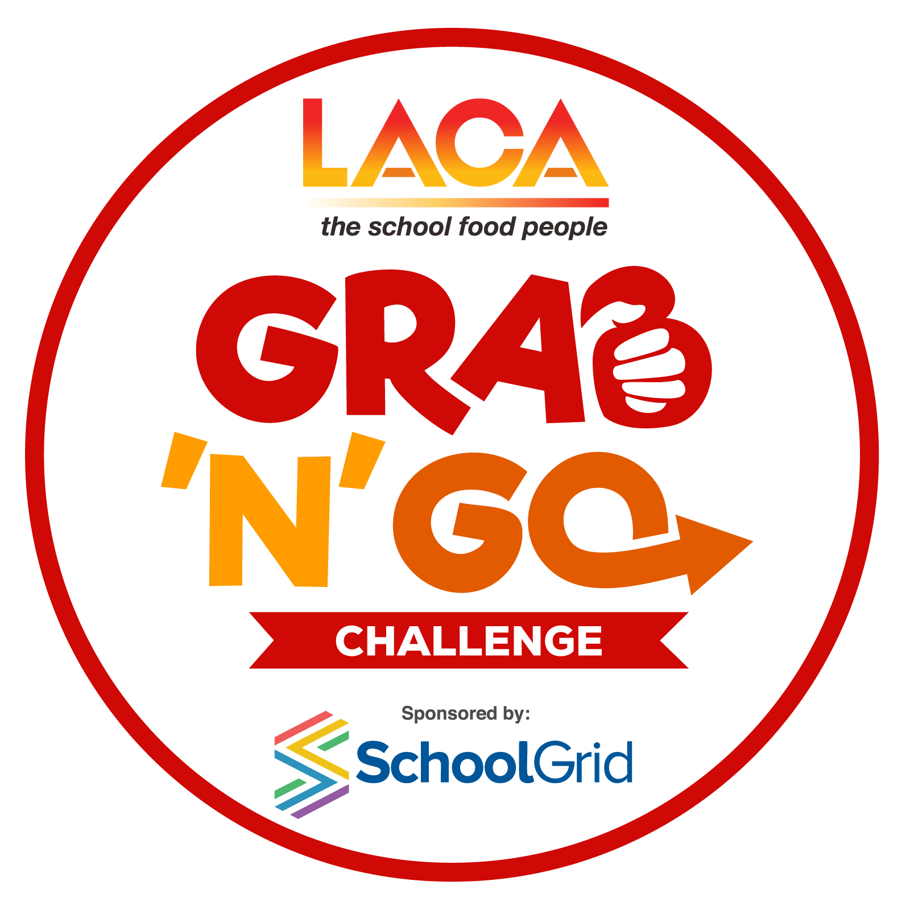
LACA GRAB & GO COMPETITION 2024
- ENTRY CHECKLIST

DEVISING YOUR MENUS

- Make sure you have read the rules and criteria in the entry pack.

- The judges are looking for skills and innovation in the use of chosen ingredients, preparation, cooking and presentation of dishes.

- The menu meal cost is a maximum of 80p for one portion. NB: contestants should use the full allowance for their menu, there are no extra points awarded for using less than the full allowance.

- A Standard Ingredient Costing Sheet is provided – you must use the costs from this sheet if using any of the ingredients listed. Other ingredients not on the list can be used but must be costed correctly and evidence of your costs may be requested. Please note – all ingredients must be costed even those used from a school garden or allotment, no free ingredients permitted.

- The method should give step by step instructions on how to create your dish and clearly show the skills being used in this recipe. Include oven temperatures and cooking times. Cross reference the costing sheets and method to make sure all ingredients are listed on the costing sheet and included in the method and vice versa.

- If you give your dish a title, please also include a menu description which should reflect the ingredients of the dish using a minimum of five and maximum of 15 words. This should be given on the costing sheets.

COMPLETING YOUR ENTRY FORMS

- There are two forms to complete to submit your entry:
  - Entry Form which includes contestant details, recipe method and pupil feedback.
  - Recipe and Costing spreadsheet.

- Weights or measurements for all items should be used, rather than quantities eg 50g onion as opposed to 1 onion.

- Eggs - If you are using egg, this should be shown as 100g of egg in the quantity column to give the correct costing per egg of 24p. If using only ¼ or ½ an egg in a dish, the whole egg must be costed on the recipe and you should show where else in the menu the remaining egg is being used to avoid losing marks for wastage.

- Herbs and spices – please specify if fresh or dried herbs are being used to enable the judges to assess if the correct weight has been given. If using pepper or chilli, please specify whether ground/dried or fresh.

- It is important to show an appropriate garnish to the recipe to enhance presentation. The cost of the garnish must be included on the costing sheets.

- The method for all dishes should be written in full. Judges will be looking to see the skills used in completing the dishes and where each listed ingredient is used in the finished dish.

- All documents should be typed, not handwritten.

- The photograph/s of your dish should be attached as separate files, not pasted into the Entry Form or costing sheet.

SUBMITTING YOUR ENTRIES

- Carefully check all completed forms prior to submission. The spreadsheet contains formulas which calculate the cost per item and divide by four at the bottom to give the total portion cost.

- Pay particular attention to spelling of names, recipes, accuracy of quantities and consistency when transferring information across the different forms.

- Entrant details using the forms provided must be returned to the competition organiser no later than Friday 5th April 2024.

Finally if you have any questions please either call or email the competition Organisers:

Tel: 0203 398 0193
Email: jor@dewberryredpoint.co.uk

