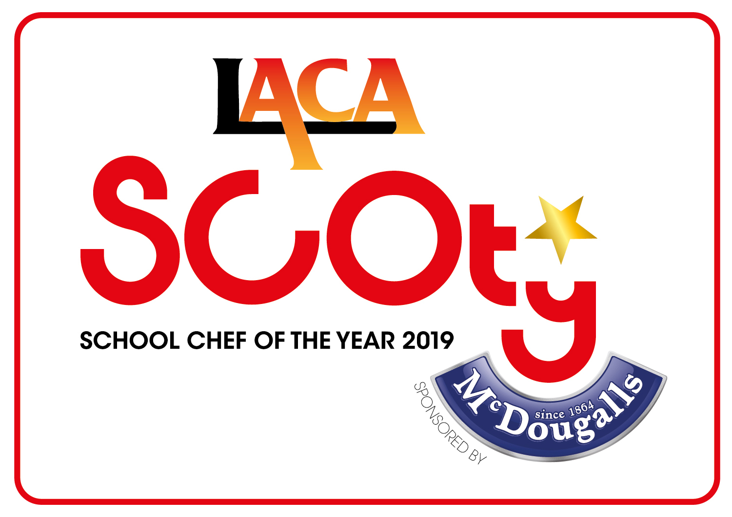
SCHOOL CHEF OF THE YEAR COMPETITION 2019

SPONSORED BY McDOUGALLS

EAST OF ENGLAND REGIONAL FINALISTS

DATE: TUESDAY 27TH NOVEMBER 2018

VENUE: PREMIER FOODS, ST ALBANS

Name of Organisation | Contestant Name | Contestant School | Main Course | Dessert
HCL Ltd | Katherine Bridge | Breachwood Green JMI School  Oxford Road Breachwood Green  Hitchin  SG4 8NP | Korean Flapjack Pork  served with steamed bao bun, sweet potato noodles, kimchi rainbow vegetable salad | Jaffa mousse brownie with a piped lace biscuit  Chocolate brownie base with a glazed orange mousse, segmented oranges and piped lace biscuit
LBC Catering | Victoria Hammond | Southfield Primary School  Pastures Way  Luton  LU4 0PE | Tandoori infused chicken with Eastern turmeric bread and raita served with spiralised vegetables | Hidden parsnip and chocolate brownie with orange five ways
Norse Catering | Annalisa Grief | West Winch Primary School  Back Lane West Winch  Norfolk  PE33 0LA | Chicken and Chorizo Hot Pot with Rosemary Bread  Chicken and chorizo hot pot topped with sliced potato and served with broccoli and carrots | Chocolate and Lime Brownie  Chocolate and lime brownie with a berry coulis
Vertas | Vicky Sear | Newmarket Academy  Exning Road  Cambridge  CB8 0EB | Spiced chicken patty, beetroot bun, baked sweet potato chips and beetroot tzatziki  Chilli and coriander spiced chicken patty in a beetroot bun, baked sweet potato chips and  beetroot tzatziki | Sub(lime) Cheesecake  A meringue topped lime cheesecake, lime jelly and berry coulis

