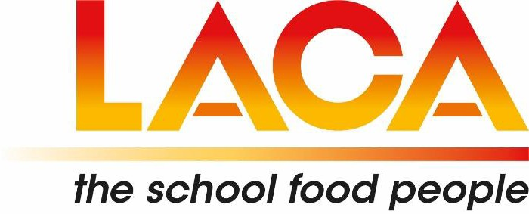

**15TH ANNUAL MEMBERS MEETING**

**TO BE HELD ON TUESDAY 17TH SEPTEMBER 2024 AT 2:30 PM  
 VIA ZOOM MEETING**

The Company AGM for LACA Ltd is held by the Board of Directors in September of each year. The purpose of the Annual Members meeting is for Members to receive reports from the Directors of the Board, of action taken during the past year - to include a report on the annual accounts of the Association and other such matters, and to seek views from the membership. The Board also seek endorsement from the Members of elections to/of the Board.

**AGENDA**

1. Apologies for absence

2:30 pm

1. Minutes of the last Annual General Meeting held 19th of September 2023
2. Chair’s Report (JG)
3. Working Group updates
   * Membership Services Group (BB)
   * Communications Group (MH)
   * Events Group (NP)
   * Finance & Administration Group (HW)
4. Statement of Accounts for 2023 (HW)
5. Recommendations for membership fees for 2025 (HW)
6. Confirmation of the board position of National Vice-Chair and Vice Chair Elect (JG)
7. Appointments and Resignation of Directors and the confirmation of Regional representatives (HW)
8. To receive and agree nominations from the Board for Honorary Life Memberships of the Association and nominations for Regional Honorary Life Membership (JG/NP)

Meeting Close 3:15 pm