LACA AUTUMN BUSINESS SEMINAR
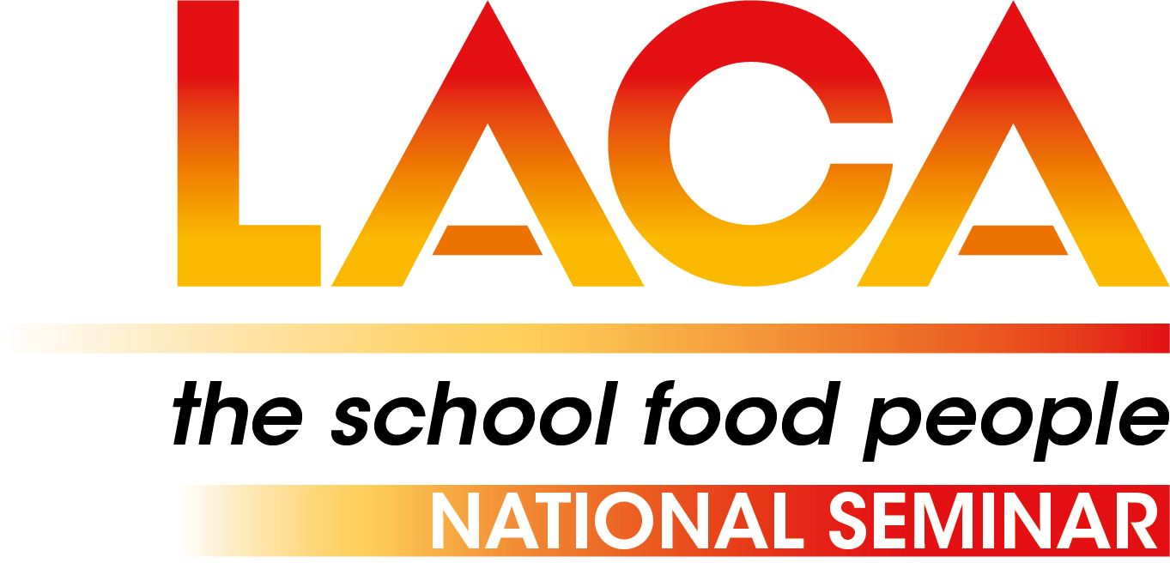
Friday 17th November 2023
Stratford Manor Hotel,
Warwick Rd, Stratford-upon-Avon CV37 0PY

SEMINAR PROGRAMME

09.00 Arrival, registration and coffee

09.30 Welcome – Neil Porter, Chair of Events Group, LACA Ltd followed by
Aims of the day, LACA Update
Anita Brown, LACA National Chair
Anita will kick the day off with an update on LACA’s strategy and focus for the coming year including the LACA’s ongoing campaigns of If Not Now When and The Sums Don’t Add Up.

10.00 Catering for Climate Change: What's the Goal and How to Get There?
Angela Tregear

10.30 SCOTY 2024 launch
Raheem Morgan, the 2023 LACA School Chef of the Year will talk about his experiences of the competition leading up to being announced as the 2023 winner and gives his hints and tips for anyone thinking of entering for 2024.

10.45 Love British Food – how to get involved

11.00 Coffee Break

11.30 Testing new ideas to increase the uptake of free school meals in Wales
Dr Jonathan Bone, nesta
This session will cover the work being done by Nesta, the UK's innovation charity, to find ways to engage parents and children in the school meal offer and increase take up. Jonathan Bone will provide insights on findings from recent work with parents and children that tested different interventions to increase the appeal of school meals. He will also offer initial insights off the back of a universal school meal take up month Nesta is trialing in October in one local authority.

12.00 Social Media Workshop
Gail Walker, Open Door PR
How you can get involved with LACA’s social media activity and how effective use of social media can highlight the great work within the school meals sector.

12.20 Case Study 1 – Solihull MBC

12.40 Case Study 2 – The Pantry

13.00 Case Study 3 - Food bank – what happens to food at the ME

13.20 Closing Remarks
Lunch and depart

Reserve – Food waste at ME

