Wales Regional Meeting Event Booking Form
VENUE: All Nations Centre

DATE: Wednesday 20th February 2019

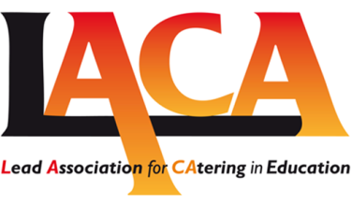
Please tick to indicate as appropriate: -
I confirm my attendance |  | I regret that I am unable to attend

Name:
Company / Authority:
Address:
Email Address:
Telephone Number:
Payment is due in advance for all Regional Meetings

Membership No:
Number Attending: |  |  | £48 incl VAT per person paid in advance only
Payment Options:
- BACS payment: HSBC Cardiff, Account No. 32793660 / Sort Code 40-16-15

- Please tick if you require a receipt (Ensure address details completed above)

Cancellations must be notified at least 7 days prior to the meeting.

Please return to:
Angharad Davies,
Email: angharad.davies@chfoods.co.uk

To be returned by Tuesday 12th February 2019

