LACA NATIONAL SEMINAR
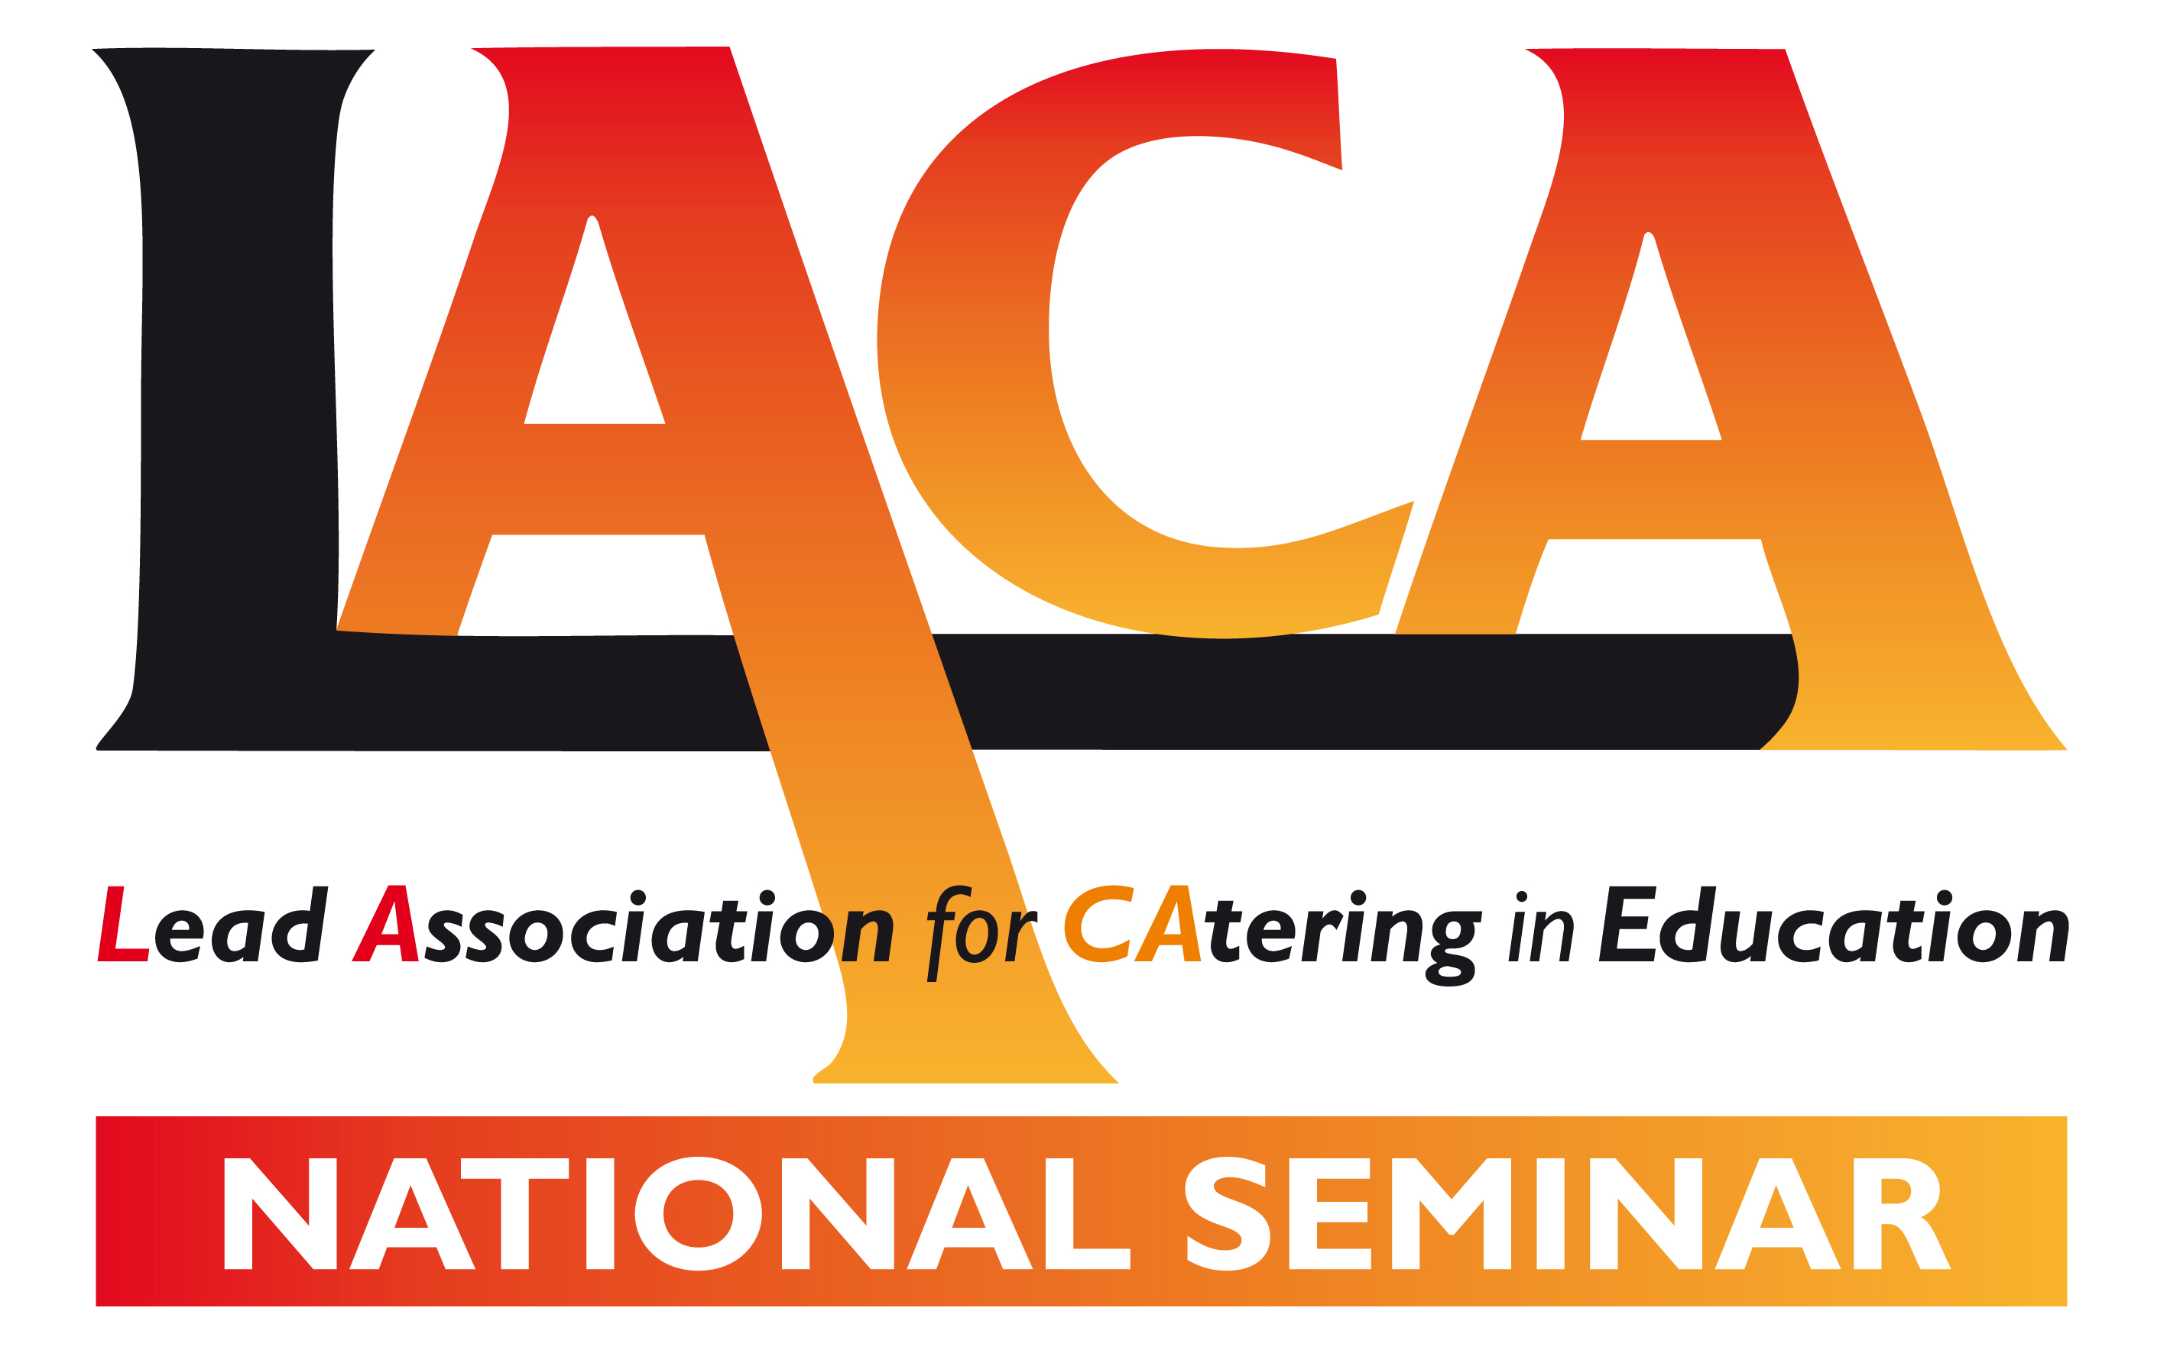

STRATFORD MANOR HOTEL, WARWICKSHIRE
friday 3rd march 2017

PLEASE COMPLETE IN BLOCK CAPITALS, USING ONE FORM PER DELEGATE
Delegate Name
Job Title
Company Name
Invoice Address

Telephone Number
Mobile Number
Email Address
Purchase Order no: |  | LACA membership no:

PACKAGE | RATE | Please tick box to book
Full-LACA Member  Please book my place at the LACA National Seminar. | £35 + VAT
Non-LACA member or School Meal Provider  Please book my place at the LACA National Seminar. | £55 + VAT
Associate Member or LACA Partner  Please book my place at the LACA National Seminar. | £70 + VAT
Please book accommodation at Stratford Manor Hotel on Thursday 2nd March 2017 | £95 + VAT
Please book a place at the SCOTY presentation dinner at Stratford Manor Hotel on Thursday 2nd March 2017.  I am a full LACA Member or LACA Partner | £60 + VAT
Please book a place at the SCOTY presentation dinner at Stratford Manor Hotel on Thursday 2nd March 2017.  I am a non-member school meal provider or  LACA Associate Member | £75 + VAT
I would like to attend the LACA Member’s Forum on the afternoon of Friday 3rd March 2017  (this option is not available to non-LACA Members) | FOC
Signature: |  | Date:
Please return this form by email to lauras@dewberryredpoint.co.uk
Booking Terms & Conditions:
The total amount will be invoiced to the address at the top of this booking form upon receipt.

Unfortunately we can’t offer a refund on cancellations, although we can accept substitutions up to the date of the event. Any changes should be made in writing. All delegate places must be paid for in full before the date of the event.

