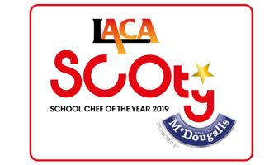

SCOTY 2019 –

Main Course and Dessert method
Rule 11 explanation of your menu

Name of Organisation/School |  | LACA Region
Entrant Name |  | School name

Main Course method:
This should give step by step instructions on how to create the main course and clearly show the skills being used in this recipe. Make sure all ingredients are listed on the costing sheet and included in the method. Please list all allergen ingredients used within your main course on the allergen chart included and submit with your entry forms.

Dessert method:
This should give step by step instructions on how to create the main course and clearly show the skills being used in this recipe. Make sure all ingredients are listed on the costing sheet and included in the method. Please list all allergen ingredients used within your main course on the allergen chart included and submit with your entry forms.

Rule 11 explanation of your menu, to include:
- What inspired you to create the dishes?
- The reasoning behind the product application of the McDougalls products you have used in your dishes
- What changes to the ingredients, method or skills would need to be made when the menu is produced en masse?
- Where sustainable products or locally sourced ingredients have been used.

Maximum 150 words permitted. This information will be displayed on the photography table at the regional final and national final stages of the competition.

Submit this form along with your Entrant Details, the Main Course and Dessert Menu Recipe & Costing Sheets and the FSA Allergen information

tick list sheet to the SCOTY Competition Organiser
NO LATER THAN WEDNESDAY 17TH OCTOBER 2018
By email to scoty@dewberryredpoint.co.uk

