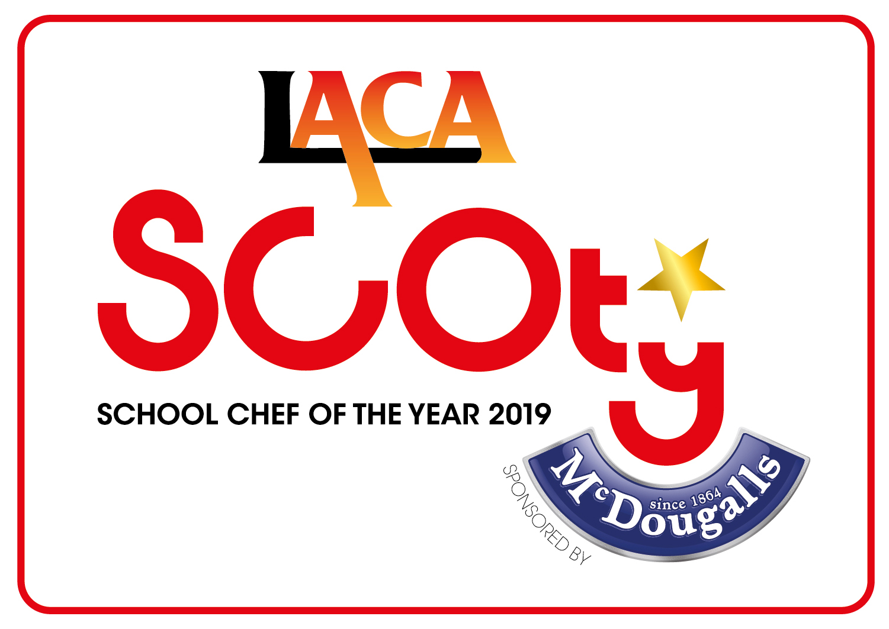
SCHOOL CHEF OF THE YEAR COMPETITION 2019

SPONSORED BY McDOUGALLS

NORTH WEST REGIONAL FINALISTS

DATE: FRIDAY 7TH DECEMBER 2018

VENUE: FIELDEN CAMPUS, MANCHESTER COLLEGE

Name of Organisation | Contestant Name | Contestant School | Main Course | Dessert
Citywide Services,  Salford City Council | Rebecca Garvey | St Josephs RC Primary School  St Joseph's Drive Ordsall  Salford  M5 3JP | Carrot ravioli with garlic foccacia and ribbon salad  Carrot ravioli with spinach, garlic and ricotta filling with tomato and red pepper sauce | Apple Bavarois  Apple bavarois on a sponge base, apple puree topped with cream and dehydrated apple thins
Lancashire County Council | Paolo Loparco | Charles Sear Primary School  Grange Road Fleetwood  Lancashire  FY7 8DD | Crespelle minced beef with spinach and vegetables  Rolled crepe filled with minced beef and spinach with tomato sauce and vegetables | Panna Cotta Crumble  Creamy Italian custard crumble served with fruits of the forest
Manchester Fayre | Cheryl Allen | St Mary's CE Primary School  St Mary's Road  Moston  M40 0DF | Beef Whirl with carrot and potato mash, broccoli and meaty gravy  Beef mince and vegetables rolled in a scone dough, with vegetable accompaniments and meaty gravy | Peach tartlet with kiwi, lime, mango and peachy fruity salsa and edible flower decoration  Pastry filled with custard and fruit puree, peaches and orange jelly topping, with fruit accompaniments
Sefton Catering Services | Holly Charnock | Woodlands Primary School  Woodlands Road Formby  Liverpool  L37 2JN | Traditional Hearty Scouse Pie and Gravy with Roasted Winter Vegetables  Beef and potato scouse pie with pickled cabbage, thyme roast swede and honey glazed carrots | Pizza for pud!  Pizza base topped with strawberry coulis, poached pear, raspberries and crumble served with strawberry Greek yoghurt

