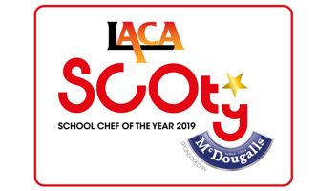

SCOTY 2019 - Regional Finals

REGION | DATE | VENUE
East of England  X 4 competitors | Tuesday 27th November 2018 | Premier Foods, St Albans
South East  X 8 competitors | Wednesday 28th November 2018 | Premier Foods, St Albans
London  X 7/8 competitors | Thursday 29th November 2018 | Premier Foods, St Albans
North West  X 4 competitors | Friday 7th December 2018 | Fielden Campus, Manchester College
West Midlands  X 5 competitors | Thursday 10th January 2019 | Stoke upon Trent College
East Midlands  X 4 competitors | Date tbc | Venue tbc
Yorkshire & Humber  X 6 competitors | Wednesday 16th January 2019  Morning heat | Doncaster College
North East & Scotland  X 3 competitors | Wednesday 16th January 2019  Afternoon heat | Doncaster College
South West  X 5 competitors | Wednesday 23rd January 2019 | Weston College
Wales  X 2 competitors | Wednesday 23rd January 2019 | Weston College

