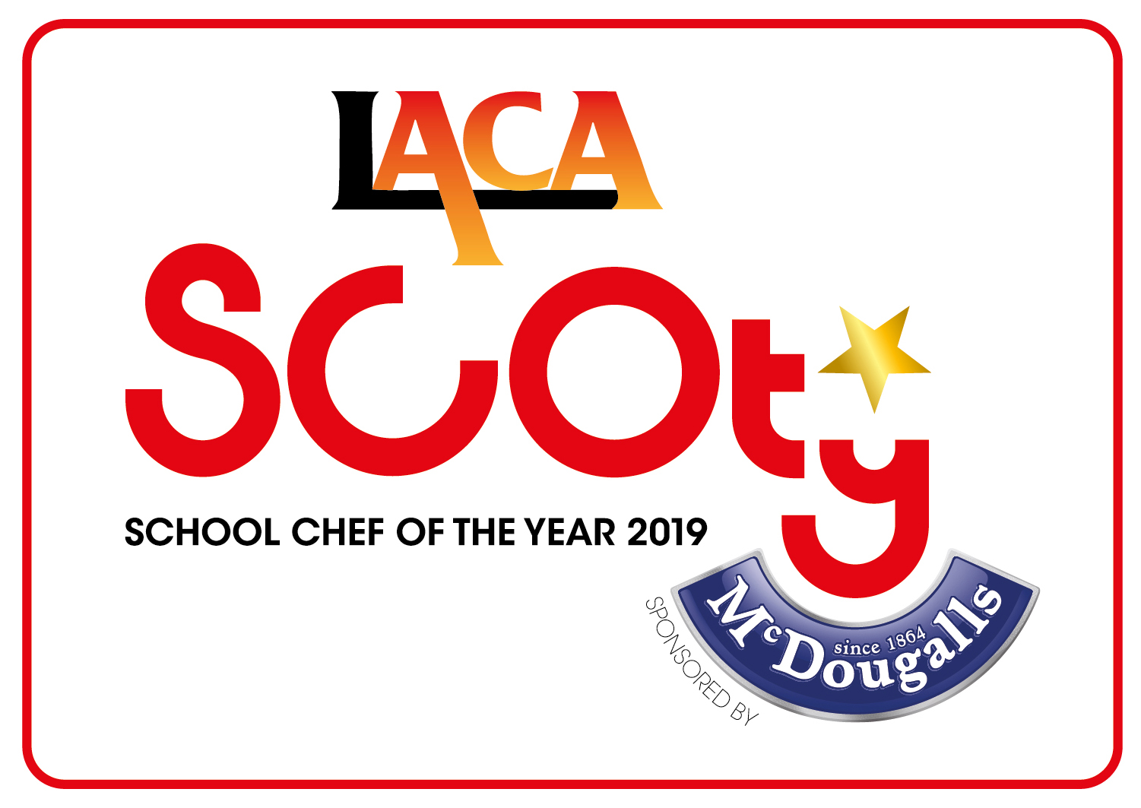
SCHOOL CHEF OF THE YEAR COMPETITION 2019

SPONSORED BY McDOUGALLS

SOUTH EAST REGIONAL FINALISTS

DATE: WEDNESDAY 28th NOVEMBER 2018

VENUE: PREMIER FOODS, ST ALBANS

Name of Organisation | Contestant Name | Contestant School | Main Course | Dessert
Caterlink - Shinfield Infants | Kelly Millns | Shinfield Infants  RG2 9EH | Fish is Swish  Fish on a bed of cabbage and locally sourced vegetable noodles topped with a ginger and courgette steam dumpling and a side of sweet chilli | Banana Bake is the Cake  2020 sugar compliant banana cake with lemongrass infused custard and strawberry topping.
Chartwells | Richard Porter | Relief Cook, Chartwells East Sussex Contract | Thyme for Chicken  Pan-fried chicken with lentil casserole and dumplings served with saute potatoes and steamed vegetables | Coconut Rice & Lime Jelly Dish  Vanilla & Coconut rice with a lime jelly disc
Gatten and Lake Primary | Leanne Bonner | Gatten & Lake Primary School  78 Oaklyn Gardens Shanklin  Isle of Wight  PO37 7DD | Chilli Chicken Lasagne  Lasagne served with a garlic and herb plait, Mexican corn and mixed leaf salad | Chocolate sponge and mandarin puddle  A light chocolate sponge with a mandarin puree puddle
HC3S | Alison Dombrick | Bentley Primary School  School Lane Bentley  Farnham  GU10 5JP | Sicilian Fish and Watercress Tart  Pollock and watercress tart, roasted veg, sweet potato fries, pea puree and tomato sauce | Oeufs a la neige  Snow eggs on custard, cherry compote, cherry sauce, chocolate brownie crumb, orange jelly pearls, sugar cage
ISS Education | Cheryl Humphries | High Weald Academy  Angley Road Cranbrook  Kent  TN17 2NY | Steamed pork bun, sesame noodles and sweet 'n' sour cucumber  Tasty steamed Chinese pork buns with sesame noodles and refreshing cucumber salad | Jelly & Ice Cream  Cool mango and coconut ice cream, jelly cubes with assorted meringues
Park Community School | Steven Cross | Park Community School  Middle Park Way Havant  Hampshire  PO9 4BU | Rocking Moroccan Chicken  Rocking Moroccan Chicken is marinated chicken chargrilled and served with homemade Moroccan flatbread and roasted harissa vegetables garnished with mint yoghurt, Nasturtium flowers, chilli and mint | North African Rose (Cheese Cake)  North African Rose is a rosewater and cardamom cheese cake accompanied by blood orange, chocolate and mint.
Surrey Commercial Services | Josefine Austin | Beacon Hill Primary School  2 Beacon Hill Road Beacon Hill  Hindhead  GU26 6NR | Swedish Meatballs  Beef meatballs served with mashed potatoes, carrot and courgette ribbons with a creamy sauce | Pineapple Tart  Pineapple tart served with vanilla crème, sweet pineapple slices and a coconut crumble

