LACA School Chef of the Year 2022
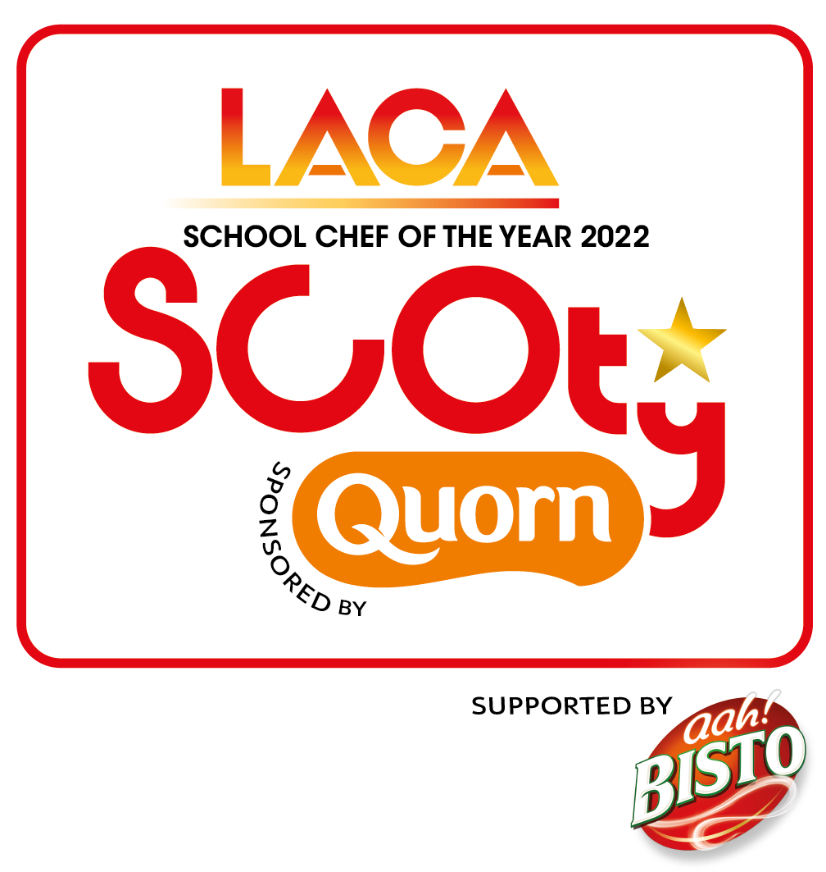

List of Quorn products for use in the competition entries, with their allergens.

These should be added to the allergen chart which should be included with your full entry for the competition.

One of the products from the Core Range must be included in BOTH the Grab & Go item AND the main course.

 | Celery | Cereals  contains Gluten | Crustacesans | Egg | Fish | Lupin | Milk | Molluscs | Mustard | Tree Nuts | Peanuts | Sesame Seeds | Soybean | Sulphur Dioxide & Sulphites
Core Range:
Quorn Vegan Fillets |  | Yes
Quorn Pieces |  |  |  | yes
Quorn Mince |  |  |  | yes
Quorn Vegan Sausages |  | Yes
Quorn Beef Pieces |  | Yes
Deli Range:
Quorn Vegan
Chicken Free Slices
Quorn Vegan
Smoky Ham Slices

