LACA SPRING BUSINESS SEMINAR
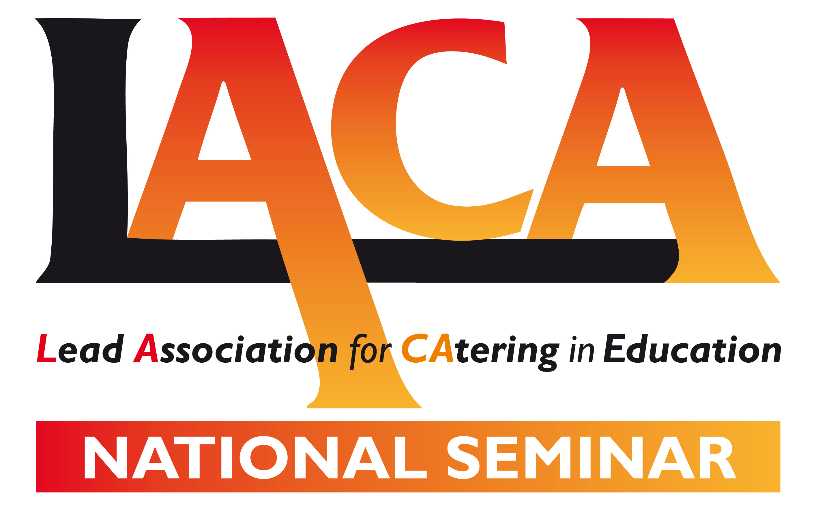
Friday 3 March 2017
Venue: Stratford Manor Hotel,
Stratford upon Avon, Warwickshire CV37 0PY

SEMINAR PROGRAMME

09.00 Arrival, registration and coffee

09.30 Welcome – Neil Porter, Chair of Events Group, LACA Ltd
Aims of the day – Sally Shadrack, LACA National Chair

09.40 Update on Apprenticeships
Julie Barker, Director of Accommodation & Hospitality Services, University of Brighton
An overview of the new apprenticeship levy, the hospitality industry apprenticeship scheme and quality standards. Julie will present all the key facts and latest information for school caterers on how best to operate an apprenticeship scheme.

10.15 Interview with the new LACA School Chef of the Year

10.45 Coffee break

11.15 LACA Update including an update on the LACA research project evaluating the impact of
UIFSM on health and attainment.
Sally Shadrack, LACA National Chair

11.40 School Workforce Development Professional Standards
Anne Bull, LACA National Steering Group
Developed and supported by leading figures in the sector to improve the image and raise the profile of school food within the wider catering industry, the professional standards clearly define the requirements that underpin the delivery of quality school food creating a consistent standard for five key roles.
Anne will provide an update that will include an overview of the recently launched Recognition Scheme outlining how your organisation can achieve recognition for using the Professional Standards.

12.00 Secondary School Catering Makeover
Julian Edwards, Chair, Foodservice Consultants Society International
Helen Blunden, Bursar, Wavell School, Hampshire
Following the launch at the Autumn Seminar, Wavell School in Hampshire was selected as the school to work with the FCSI. Julian and Helen will update delegates on how the makeover is taking shape in its early stages.

12.15 Case study: Lancashire County Catering on their school meal recipe competition
Alison Ashton, Skills and Standards Trainer, Lancashire County Council
After a break of a few years, Lancashire County Council went to regional final success in the 2016 LACA School Chef of the Year competition with entries from nine of their school chefs seeing their contestant go through to represent the North West region at the national final. They have achieved this success by holding a competition locally among their chefs to devise a winning menu which is then rolled out across their schools and entered into the national competition. In this session, find out more on how you could implement a similar scheme.

12.45 Members Forum

13.15 Lunch and depart

