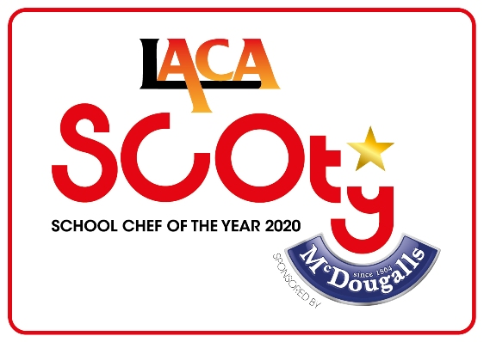

SCOTY 2020 - Entrant Details

Name of Organisation/School
LACA Region
Manager’s Name
(main point of contact for this entrant)
Telephone Number |  | Mobile Number
E-mail address
ENTRANT DETAILS:

Return this form along with the Main Course and Dessert Recipe & Costing Spreadsheets, the document giving the main course and dessert methods, the FSA allergen information tick list sheet and your Rule 11 explanation plus pictures of your dishes both on presentation plates and produced en masse to the SCOTY Competition Organiser no later than Wednesday 16th October 2019.
Please submit the full entry by email to scoty@dewberryredpoint.co.uk
If you have any questions on submitting your entry, please call the competition organisers on 0845 108 5504.

Contestant’s Name
Contestant’s age |  | Contestant’s Gender
Contact Number |  | this number will only be used in relation to the competition entry and not given out to media without prior permission

School Name
School Address

School Type
McDOUGALLS INGREDIENTS USED:
Please tick the McDougalls products used in your entrant’s recipes below. A minimum of one different McDougalls product must be used in the main course and in the dessert. This must form a significant part of the recipe, not just used as a garnish.
Product | Main | Dessert | Product | Main | Dessert
Hovis Best of Both Bread Mix |  |  | McDougalls Healthy Carrot Cake Mix
McDougalls Bread & Roll Brown Mix |  |  | McDougalls Flapjack
McDougalls Bread & Roll Mix with added wheatgerm |  |  | McDougalls Crumble Mix
McDougalls Bread & Roll White Mix |  |  | McDougalls Plain Muffin Mix
McDougalls Plain Flour |  |  | McDougalls Choc Muffin Mix
McDougalls Self Raising Flour |  |  | McDougalls Plain Cookie Mix
McDougalls Shortcrust Pastry Mix |  |  | McDougalls Choc Cookie Mix
McDougalls Pizza Base Mix |  |  | McDougalls Brownie Mix
McDougalls Soft Bap Mix |  |  | McDougalls Meringue Mix
McDougalls Fish Batter |  |  | McDougalls Orange Jelly
McDougalls Thickening Granules |  |  | McDougalls Lime Jelly
McDougalls Suet |  |  | McDougalls Blackcurrant Jelly
McDougalls Savoury Scone Mix |  |  | McDougalls Raspberry Jelly
McDougalls Scone Mix |  |  | McDougalls Strawberry Jelly
McDougalls Reduced Fat Sponge Mix |  |  | McDougalls Vegetarian Orange Jelly
McDougalls Plain Sponge Mix |  |  | McDougalls Vegetarian R’berry Jelly
McDougalls Healthy Choc Sponge Mix |  |  | McDougalls Vegetarian S’berry Jelly

