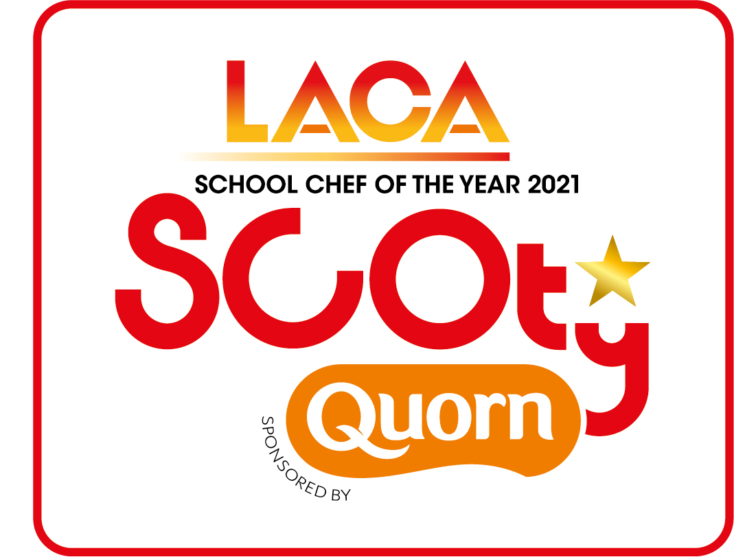
SCOTY 2021 - ENTRY CHECKLIST

DEVISING YOUR MENUS

- Study the competition rules and pay particular attention to rule 5 which relates to the School Food Standards and the Eat Well Guide 2016 and will form the basis of your recipes.

- A minimum of one Quorn product from the core range to be used in the main course. The dessert should be based on a minimum 50% fruit.

- The judges are looking for skills in preparation, cooking and presentation of dishes.

- The menu meal cost is a maximum of £1.40 for one single meal for one pupil, i.e. one main course and one dessert. NB: contestants should use the full allowance for their menu, there are no extra points awarded for using less than the full allowance. A Standard Ingredient Costing Sheet is provided – you must use the costs from this sheet if using any of the ingredients listed.

- The method should give step by step instructions on how to create both dishes and clearly show the skills being used in this recipe. Include oven temperatures and cooking times. Cross reference the costing sheets and method to make sure all ingredients are listed on the costing sheet and included in the method.

- Pay attention to any allergens within your dishes and identify any allergen ingredients on the allergen chart provided.

- If you give your dish/es a title, please also include a menu description which should reflect the ingredients of the dish using a minimum of five and maximum of 15 words. This should be given on the main course or dessert costing sheets, as appropriate.

COMPLETING YOUR ENTRY FORMS

- There are five forms to complete to submit your entry:
  - Entrant details.
  - Main Course Recipe and Costing spreadsheet.
  - Dessert Recipe and Costing spreadsheet.
  - Document to complete with the full method of both your main course and dessert and the Rule 11 explanation of your dishes.
  - Allergen checklist chart.

- Weights or measurements for all items should be used, rather than quantities eg 50g onion as opposed to 1 onion.

- Eggs - If you are using egg, this should be shown as 100g of egg in the quantity column to give the correct costing per egg of 22p. If using only ¼ or ½ an egg in a dish, the whole egg must be costed on the recipe and you should show where else in the menu the remaining egg is being used to avoid losing marks for wastage.

- Whole fruit (orange, lemon and lime) – If you are using any of these whole fruits, this should be shown as 100g in the quantity column to give the correct costing per fruit. As with egg, the whole frit must be costed on the recipe and you should show where else in the menu the remainder of the ingredient is being used to avoid losing marks for wastage.

- Herbs and spices – please specify if fresh or dried herbs are being used to enable the judges to assess if the correct weight has been given. If using pepper or chilli, please specify whether ground/dried or fresh.

- It is important to show an appropriate garnish to the recipe to enhance presentation. The cost of the garnish must be included on the costing sheets.

- The method for both main course and dessert should be written in full and a list of any allergens indicated on the chart provided. Judges will be looking to see the skills used in completing the dishes and where each listed ingredient is used in the finished dish.

- Include the Rule 11 explanation of your dish on the method document; this is a requirement of the competition and all points should be covered. Maximum 150 words to be used.

SUBMITTING YOUR ENTRIES

- Carefully check all completed forms prior to submission. The spreadsheets contain formulas which calculate the cost per item and divide by four at the bottom to give the total portion cost.

- Pay particular attention to spelling of names, recipes, accuracy of quantities and consistency when transferring information on to different forms.

- Two sets of photos are required for both your main and dessert – one to show the dish in competition presentation and the second to show how the dish would be replicated en masse on your school servery counter.

- Entrant details using the forms provided must be returned to the SCOTY competition office no later than Friday 26th March 2021. Please note we cannot extend the entry deadline as the paper judging days will be in the following week.

Finally if you have any questions please either ring or email the SCOTY Organisers:
Tel: 0208 269 7920 Email: scoty@dewberryredpoint.co.uk

