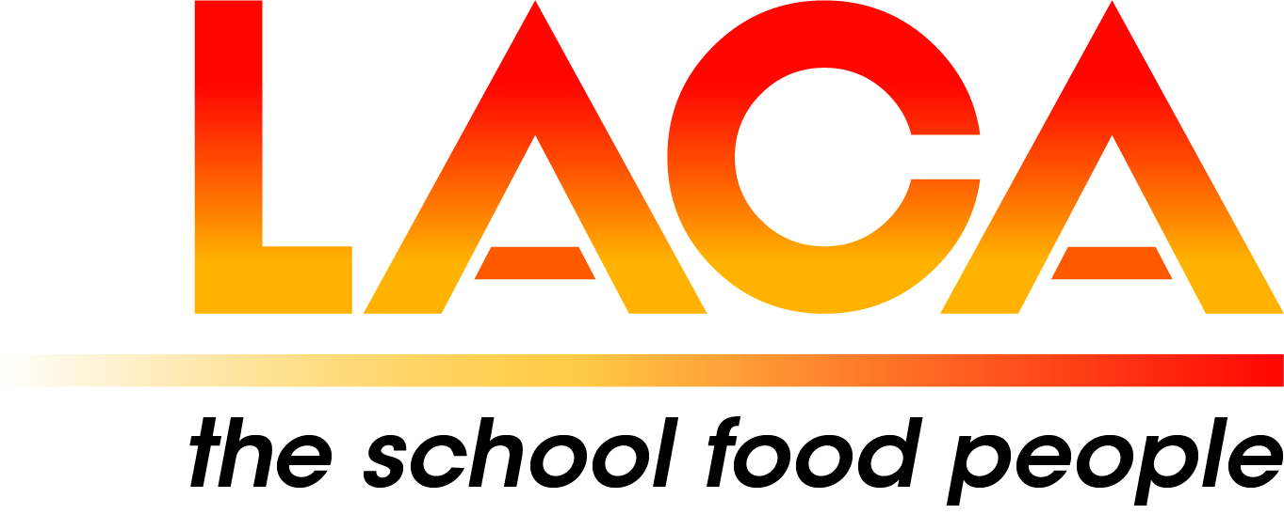

Date: 6 May 2025

Ref: LACA/KIH

Email: [kathleen.hayton@ntlworld.com](mailto:kathleen.hayton@ntlworld.com)

Mobile: 07831 693385

**West Midlands Region**

Dear Member,

**Regional Meeting on 5 June 2025 at 1.30pm via Microsoft Teams**

I refer to the diary date in my email dated 24 January 2025 and now confirm the programme and booking details for the online Meeting on Thursday 5 June 2025 at 1.30pm via Microsoft Teams.

**Programme**

1.30pm Welcome – Lorna Hicks, Chair

1.40pm ‘Eat Them to Defeat Them Campaign’ update - Soraya Ulrich-Khan, Project/Schools/HAF Manager,

Veg Power.

2.00pm The SCOTY Experience - Regional Winner 2025 – Mike Tafft, Telford & Wrekin Council

2.15pm TBC

2.35pm What’s happening in your Local Authority/ Catering Contracts/Self-Managed Schools? -

Brief reports (5 minutes) - e.g. school meal prices from September 2025, new initiatives to encourage uptake, buying up to 50% of food from UK/local sources, staffing recruitment and retention, breakfast pilots etc. - Representatives from Local Authority Caterers/ Contractors Caterers and Self- Managed Schools Caterers.

3.35pm Questions

3.45pm Close.

To book a place, please email me, **not later than Friday 23 May 2025. Please include your name, Local Authority/School/Company and email address.**

**Email: kathleen.hayton@ntlworld.com. *Lorna will send the Meeting Link a few days before the Meeting.***

I look forward to seeing you online on 5 June 2025, and especially welcome new Members.

**Diary Date:**

**Thursday 16 October 2025 Joint East & West Midlands Regional All-Day Event at Parts Town UK, Cannock**

Food for thought - an appetite for catering for special dietary requirements - IDDSI and Allergens.

This includes an Allergen update from LACA Ambassadors Tanya and Nadim Ednan-Laperouse, Natasha Research Foundation.

Yours sincerely

*Kath Hayton*

Hon. Secretary