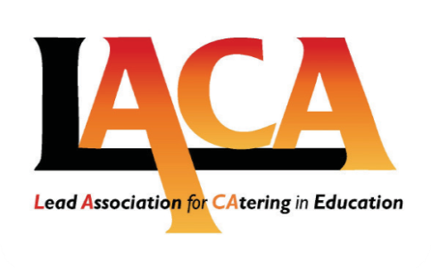
Yorkshire & Humberside
Excellence Awards

14th June 2019

Venue: Reception drinks at the Star Inn, Museum Street, York @ 6:00pm
Awards ceremony to held cruising along the River Ouse

This is a a time to recognise, reward and celebrate the hard work of School Meals providers in the
Award Winning
Yorkshire & Humberside Region

AGENDA
6:00 pm Reception drinks at the
Star Inn The City of York

Sail on the River Ouse and enjoy a celebration of Schools Catering & the people working within it

BBQ and Bar Awards
Disco and Party until 11:00pm

Charity Raffle in Aid of Sheffield Based PCAT
(Parent Association for Children
with Tumours)

