LACA Grab & Go Challenge
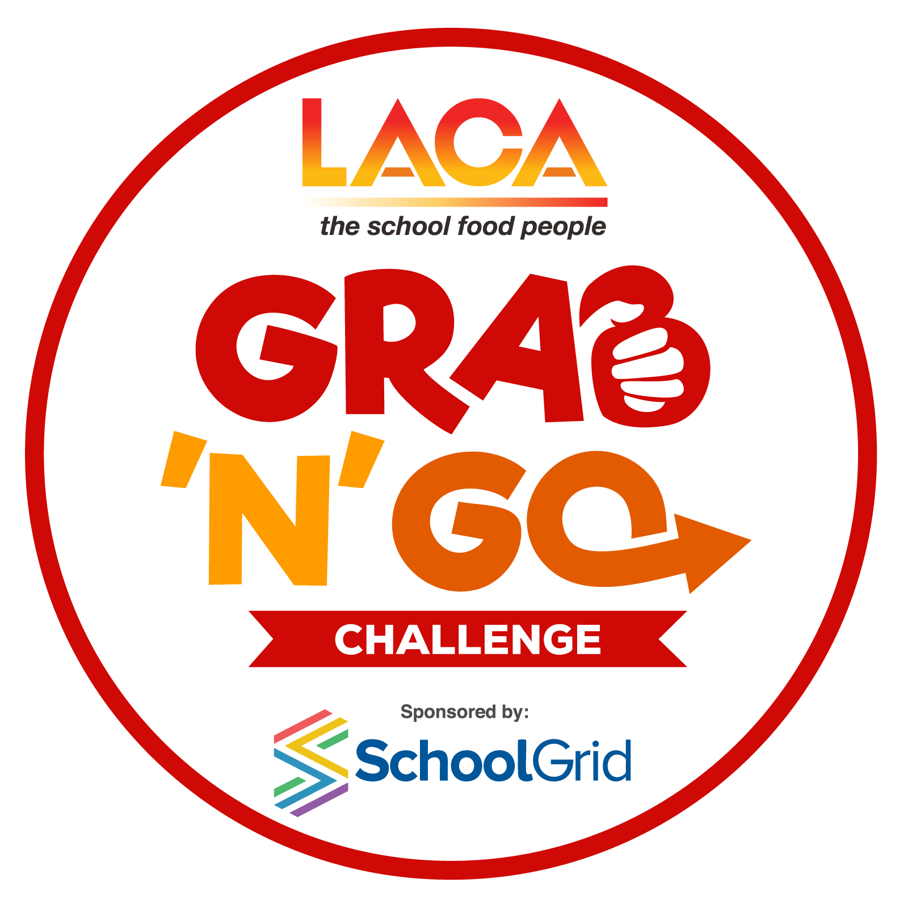
Winning Recipe by Angela McCurry, Nourish Catering
Vegan Caribbean Pasty

210g Plain Flour
100g Baking fat
20ml Water
15ml Vegetable oil
35g Cooking Onion
2g Garlic Puree
60g Sweet Potato
25g Tomato Puree
1 vegetable stock cube
20g Spinach
25g Sweetcorn
2g Cumin
2g Ginger
5g Turmeric
50g courgette
2g Black pepper
80g Red Lentils

Make filling:
sauté the onions, then add the chopped garlic and washed lentils, cook for a few minutes.
Add the spices and cook for a further few minutes then add the chunky sweet potato and vegetable stock.
Let simmer with lid on for a few minutes until the vegetables are tender - adjust water if needed at this point.
Stir in the spinach and sweetcorn and allow to cool.

Make the pastry:
Rub together the flour, baking fat and turmeric until it resembles breadcrumbs then slowly bind together with water adding little by little until you have a smooth paste (be careful not to add to much water) then wrap in cling film and leave in the fridge to rest.

To build the pasty:
Roll out the pastry and cut into four circles using a round 19 to 20 cm plate.
Then add spoonful of the cooled mix into the centre of the pastry and carefully wet the outer edges with a pastry brush and water.
Bring the pastry around the mix and seal at the edges making a half-moon shape.
Now using a fork press lightly on the edges to seal the pastry and create a pattern.
Brush water over the top of the pasty and cook in pre heated oven for 20 mins at 180oc to 200oc.
until the pastry is golden in colour and cooked through check the underside of the pasty.

