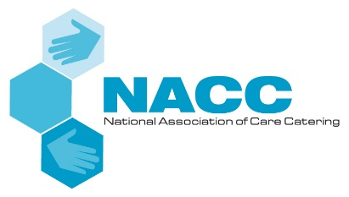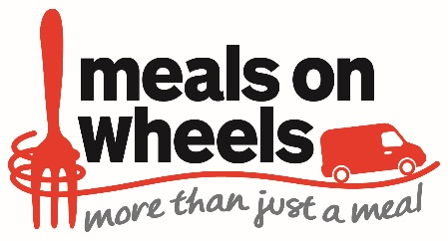

NACC CORONAVIRUS MEALS ON WHEELS CASE STUDY QUESTIONNAIRE

Thank you for taking part in the NACC Meals on Wheels Heroes case study. Please complete the questions below and return, with supporting images, to Neel Radia neel@neelradia.com

REQUIREMENTS:
- Please complete the contact details section in full. Once the case study is written, we will return it to you for final approval before it is used. We will also tag you into any social media activity about your case study.
- Please complete the questions below applicable to your business, as indicated.
- Please provide images that bring your service to life – e.g. image of premises, team members, volunteers, food, customers, etc.

CONTACT DETAILS:

Name:

Contact email:

Contact telephone number:

Social media handles:

QUESTIONNAIRE:

About your business:
- What is the name of your business?
- Are you usually a Meals on Wheels operation?
  - Yes? Answer the questions for ‘Meals on Wheels providers’ (in blue font)
  - No? Answer the questions for ‘Other Hospitality Businesses’ (in green font)

QUESTIONS FOR MEALS ON WHEELS PROVIDERS:

- Please provide an overview of your Meals on Wheels operation pre-coronavirus – for example:
  - What area do you cover?
  - How many clients do you have?
  - How many meals do you deliver daily?
  - Do you deliver every day of the week?
  - How many team members/volunteers?
  - Do you deliver hot and/or cold meals? Give some examples
  - What is the cost of a meal?
  - What social interaction/wellbeing checks do you offer?
  - Any other important information about your operation – e.g. other community work, partnerships, award wins etc?

- Tell us about your Meals on Wheels operation during the pandemic – for example:
  - What was the increase in demand?
  - Did you have more team members/volunteers?
  - Did you offer the same service or did this change? E.g. menus, meals per day etc, addition of essential packs etc?
  - Did you have any supply issues? If yes, how did you overcome these?
  - How did you meet the challenges of social distancing when cooking and delivering?
  - Any new innovations/practices as a result of the pandemic?
  - Were you still able to offer customers the social benefit of a delivery? Please give examples.
  - What was the response/feedback of customers – both old and new? And their families?
  - What did you and the team get out of your important contribution to the pandemic frontline effort?
  - Any other important information?

- What do you think the future of your service looks like as the pandemic continues and restrictions ease?

QUESTIONS FOR OTHER HOSPITALITY BUSINESSES:

- Please provide an overview of your business pre-coronavirus – for example:
  - What do you do? E.g. lunch club, hotel, restaurant, pub, café, school etc.
  - Where are you based?
  - What days do you operate and what do you offer?
  - Describe the menu, with a couple of examples.
  - When are you open?
  - How many customers/covers do you serve daily?
  - Do you offer entertainment – e.g. shows, quizzes, bingo etc?
  - What is your role in the community?
  - Any other important information – e.g. award wins, standout initiatives etc.

- Tell us about your meal’s delivery service during the pandemic – for example:
  - What made you decide to deliver meals to the community?
  - How many meals a day were you delivering, to how many people and when?
  - Who was involved in the operation – e.g. team members, local volunteers etc?
  - Tell us about the service – e.g. what was it called? What food did you serve? Did you offer anything else – e.g. essential packs, social distance chats etc?
  - What was the cost of the meals?
  - How did you advertise the service?
  - Did you have any supply issues? If yes, how did you overcome these?
  - How did you meet the challenges of social distancing when creating the meals and delivering?
  - What was the response/feedback of customers and their families? Both on the food and the social interaction?
  - What did you and your team get out of setting up this service and your important contribution to the pandemic frontline effort?
  - Any other important information about the service?

- Now that hospitality is reopening and you return to your ‘usual’ business, how do you see your continued role in the community – e.g.: will you continue with any form of delivery service?

